HANOI LUXURY CITY HALF-DAY TOUR(AFTERNOON)
Hanoi is the capital of Vietnam and has been a place to keep and witness more than 1000 years of a long history.
That is why this place is a solemn ancient city. Visiting around Hanoi in the afternoon , you will see ancient architectures such as Temple of Literature, Hoa Lo Prison. All together create an ancient and historic city.
Coming to Hanoi, you not only see the architectural works but also to immerse yourself in the unique culture here.
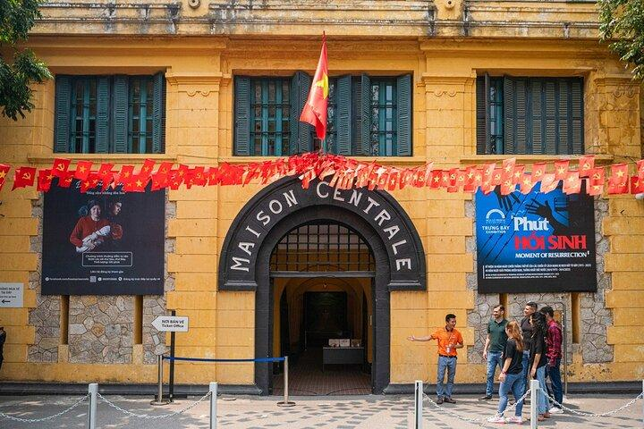

ITINERARY:
12h15: Our Tour guide and our Bus pick up at your hotel and go to the restaurant.
12h30-12h45: Have lunch at our restaurant. You have an opportunity to enjoy Vietnamese cuisine. Vegeterian foods are available.
Note: In case, Customers don’t have lunch with the tour, our Bus will pick up at the hotel at around 13h30.
13h30: Visit Tran Quoc Pagoda located on Golden Fish Island in West Lake. It is the oldest pagoda in Hanoi built in the 6th century.
14h30: Continue to visit Temple of Literature – the first university of Vietnam, The Temple of Literature (Van Mieu Quoc Tu Giam) is one of the most attractive tourist spots in Northern Vietnam. The Temple of Literature was founded in 1070.
15h30: Keep going to visit Hoa Lo Prison, the prison was built by the French, from 1886 to 1901, when Vietnam was still a part of French Indochina. The French called the prison Maison Centrale. The prison was called “A Hell on Earth” and now the prison is like a war museum for those who want to understand more about the war against France of Vietnamese people.
16h30: Our Bus take you back to the Hotel. We finish the trip!
Optional: Cyclo and/or Water Puppet Show can be arranged upon your request with additional fee.
Option 1: Cyclo 45 minutes (5usd/person) around Hanoi Old Quarter after visiting Hoa Lo Prison
Option 2: Water Puppet Show 50 minutes (5usd/person) .
- Recomended time: 16h10 or 17h20
Option 3: Cyclo 45 minutes and Water Puppet Show 50 minutes (10usd/person).
- Recommended time for Water Puppet Show 17h20 or 18h30

INCLUSION
- Shuttle Bus/Limousine during the trip
- A bottle of water / person
- Entrance tickets
- English speaking guide
EXCLUSION
- Drink for lunch
- Cyclo (USD 5/person)
- Water Puppet Show (USD 5/person)
- Tips for tour guide & driver
- Personal expenses or anything not mentioned above
SPECIAL NOTES
- For Half-day city tour, if customers don’t have lunch we will deduct USD 5/person and pick up at the hotel at 13h30.
- Should bring the necessary things such as: cash, cellphone or cameras, raincoat/ umbrella, suncream, etc (depending on the weather).
- The order of the itinerary can be changed depending on the situation.

